After putting the DVD into the computer, perform the following:
Double-click the VLC Media Player button on the desktop
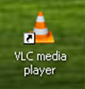
The following screen will appear. Click the Play button in the bottom left corner.
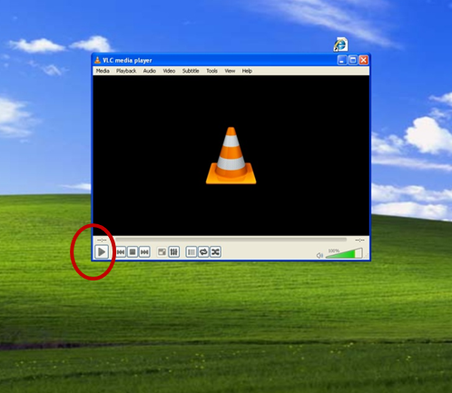
After clicking Play, the Open Media dialog box will appear.
Choose the Disc tab, then click Play
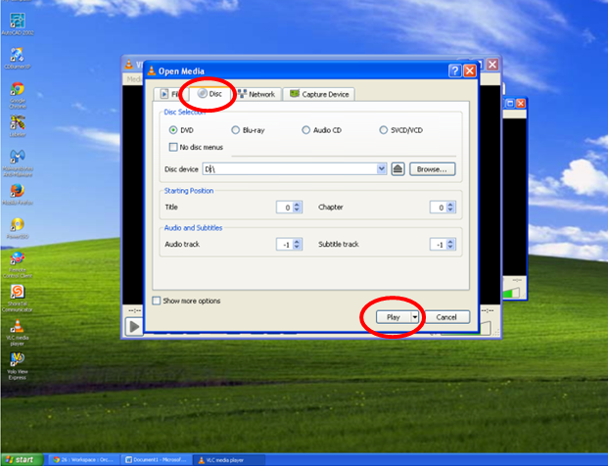
When the video starts, the VLC Media Player window may need to be maximized. Also, be sure that “PC” is chosen on the Xpanel so the video shows on the overhead projector.

